**Assignment 3**

**Points**

**This assignment is for building a calculator app which will do the basic mathematical operations. Your app should contain the following mentioned buttons:**

* **Numbers from 0-9**
* **AC to clear all and C to clear the current screen value**
* **Operands (+, -,** **÷, x, %) for mathematical operations**
* **Decimal (.)**
* **Result (=)**
* **Sign change button (+/-)**

**Please follow the following instructions to complete this assignment.**

1. Open Xcode from the launchpad of your mac.
2. Click on create a new Xcode project. Select the iOS template and click on the App application.
3. Click on next which will prompt you to choose options for the project.
4. Provide product name as **Lastname_Calculator** , “**nwmsu**” for organization identifier, “**storyboard**” as interface and swift as language.
5. Click on next and select an appropriate location to save your app and click on create. A project directory will be loaded.
6. From the project navigator click on “Main.storyboard” file, a blank mobile screen will be loaded where the required fields for an app need to be added
7. For designing the app, we need a label where the entered number and the results of the operations is shown to the user, buttons for all the numbers, buttons for operands and stacks to layout the buttons.
8. Firstly, drag and drop a label at the top of the screen from the library. Resize the label as required and clear the default text.
9. Secondly, add your preferred buttons for the first row and embed them in a stack for proper alignment. Once you complete this step your screen should look similar to below.



1. Now we need to resize the buttons, so that it fills the screen properly. Select all the four buttons (not stack) using shift + click, once selected click on add new constrain button which is at right bottom of your storyboard screen. Refer to below image if you didn’t get the button location.



Now resize the selected button’s dimensions by changing their width and height as shown in the image. You can keep any width and height, it’s up to you. Once dimensions are altered click on add constraints.

1. After completion of above step, your button’s size should have changed. You can see in the image below that AC button now have the constraints added. Now if you are re changing the width and height you will get a conflicting constraint’s error as shown in the image below.



In that case delete the constrain which you don’t need by selecting the constraint and click delete button.

1. Similarly, we need to add the rest of the buttons. Select the whole stack as shown below, do command+d which will duplicate the stack. Align it properly as required and rename the buttons. In a similar fashion add all rest of the buttons.



1. Once all the buttons are added, change the text color and background color of all the buttons as needed. Now select all the created stacks and the label, once selected embed them again in a stack as shown in the image below. This will create a vertical stack which will contain all the objects.

**Note:** It’s not mandatory to follow the same screen design as shown in the below image, it’s up to you for the placement of the buttons.

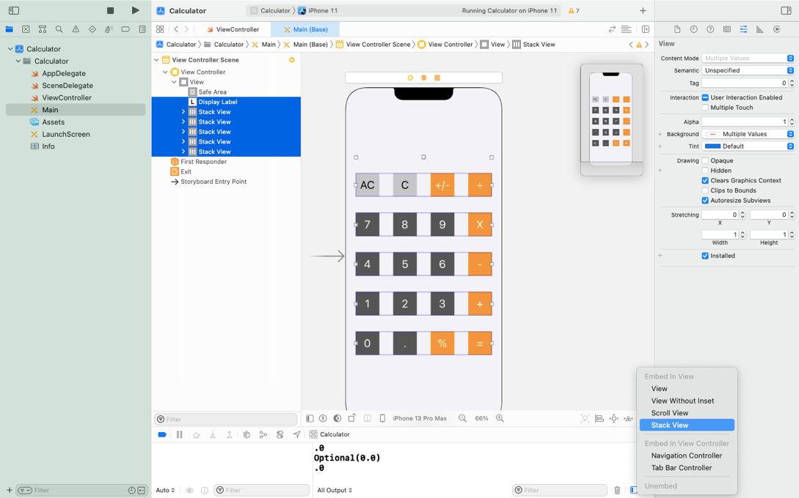

1. After completion of the above step, select the newly created vertical stack and click on the button align which is at the bottom right of the storyboard. A pop will appear as shown below, select the two check boxes and click on add constraints. This step will make the design of our app to be center aligned horizontally and vertically for any screen size. You can test this by selecting different devices in the storyboard.

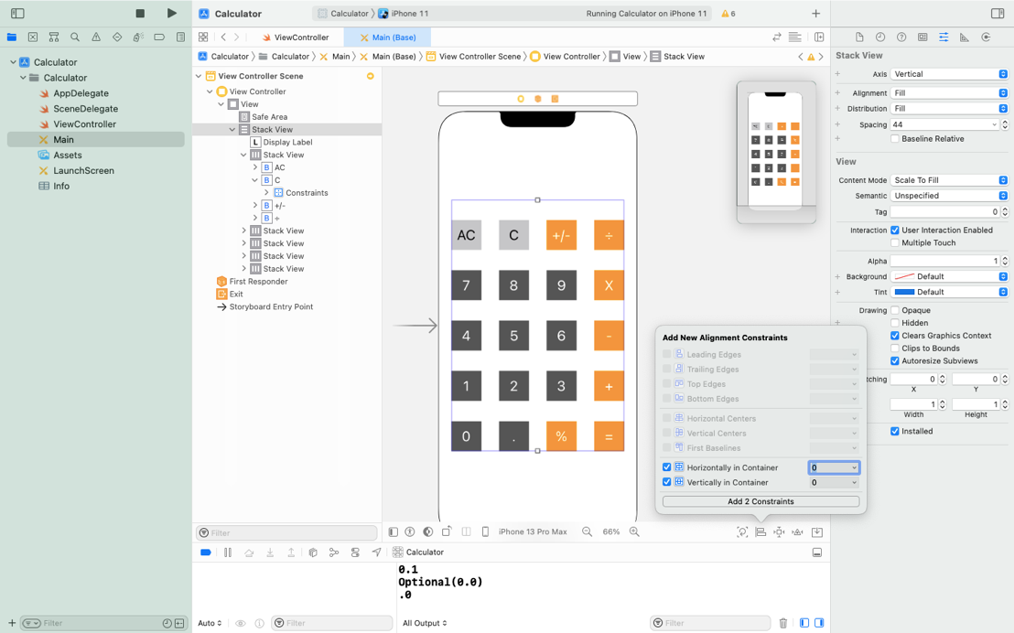

1. You have completed the design part now, you can play with the font colors, background colors if you want to make your design more attractive.
2. Now, we have to create an outlet connection for all the objects of the storyboard with the view controller.
3. First insert the label as an outlet to the viewcontroller and give the meaningful name.
4. Secondly, insert all the button’s as an action with type as UIButton. For making the connections faster, you can copy paste the already created function and rename the function name. Once renamed Click on the empty circle shown along with line numbers in the view controller code. Once selected drag to the respective function button as sown in the image below.



1. Similarly create the functions to all the buttons and link it to their respective buttons.
2. Now whenever a numeric button is clicked its respective number should appear in the label, you might need a function where you will be appending the clicked button’s number to the label. Implement accordingly.
3. Whenever an operand is clicked after the numbers are pressed, the numbers entered before the operand need to be stored in some var which can be accessible. Create a global var for the same. You can create the global var by declaring them out of the functions inside a ViewController class (Similar to java). The operand clicked needs to be globally accessible too, so store it in the suitable var type.
4. Once the operand is clicked by the user, on further number click, the label should be reassigned to only clicked number and should concatenate all the numbers thereafter.
5. On the click of “=” the app should show the result of the operation by showing the result in the displayLabel.
6. Sign change button (+/-) should change the sign of the operator and the same should be handled while doing the calculations.

**Your app should pass the following test cases to consider it as successful implementation.**

1. **13 + 45 = 58**
2. **1.3 + 1.7 = 3 (Not 3.0)**
3. **AC: Clear everything**
4. **-14 - 10 = -24**
5. **20 ÷ 3 = 6.66667 (rounded to 5 digits)**
6. **6 ÷ 0 = Error**
7. **14 + 12 C 13 = 27**
8. **6.6 % 1.3 = 0.1 (remainder of division between two numbers)**

**Please submit your app as compressed file, your compressed files should contain Lastname_Calculator folder and Lastname_Calculator.xcodeproj file. Please check your submission by downloading the submitted file and rechecking in xcode.**